Project Design Phase
Solution Architecture
Date | 09 September 2026
Student Name | Jetti Harika
Project Name | Automated Network Request Management in ServiceNow
Maximum Marks

Solution Architecture
The architecture bridges the employee/requester-facing Service Portal experience with ServiceNow application configuration, validation rules, approval tracking, and the backend network request table. List views give approvers and network teams operational visibility across the request lifecycle.
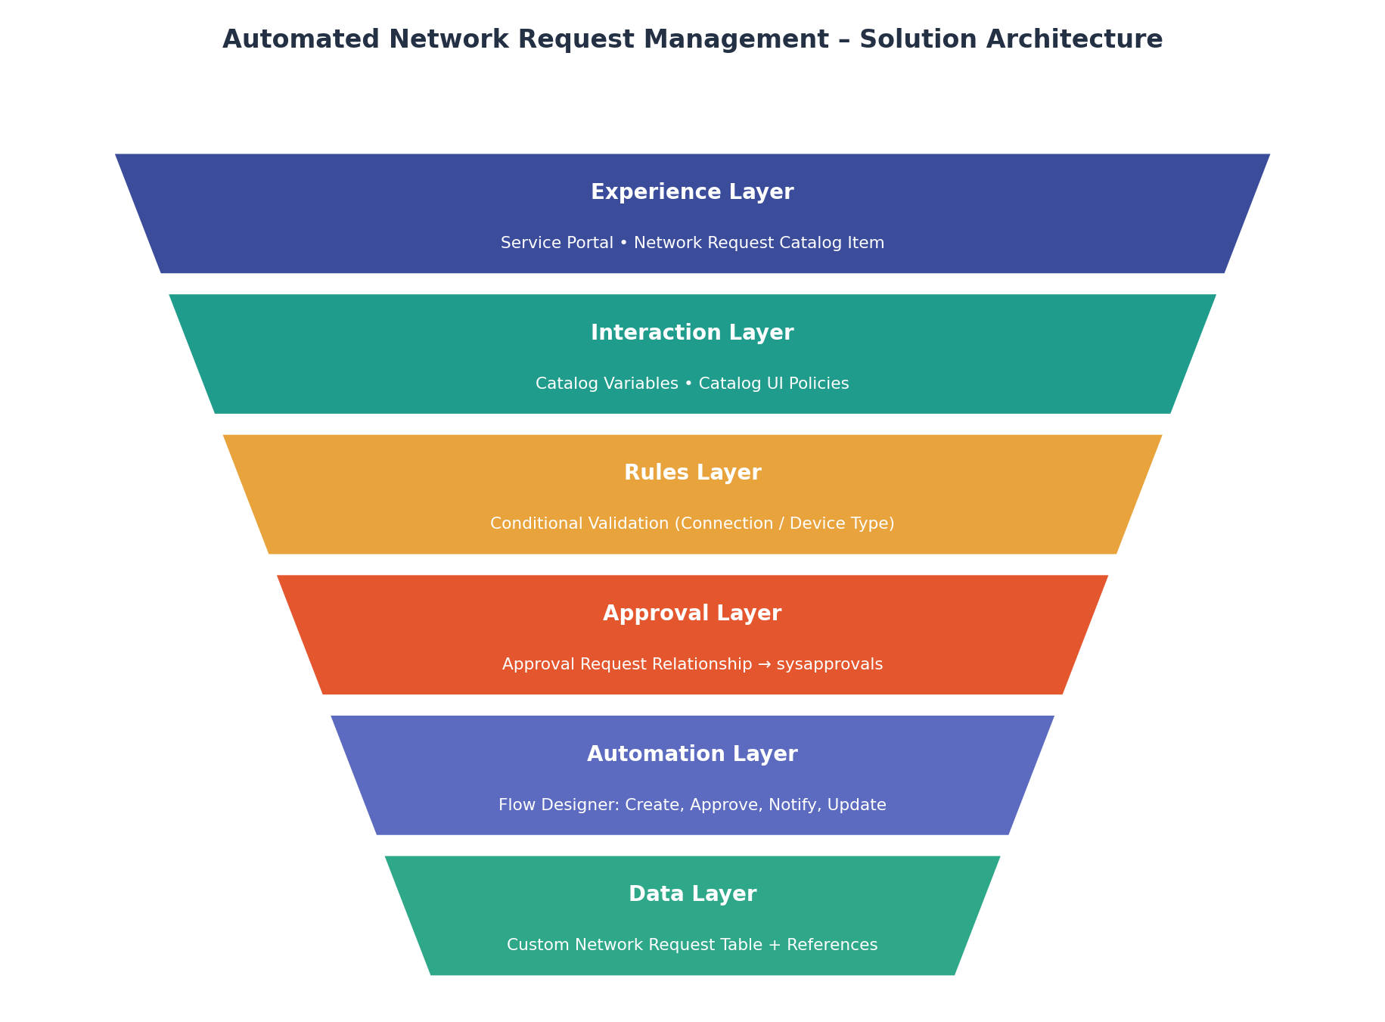
Figure 1: Automated Network Request Management solution architecture.

Layer | Components | Responsibility
Experience | Service Portal, Network Request catalog item | Provides the requester-facing submission form.
Interaction | Catalog Variables, Catalog UI Policies | Dynamically shows or hides fields based on user selections (device type, connection type).
Catalog | Network Request catalog item (order 100, 200, 300, ...) | Collects structured request variables such as request type, access level, and business justification.
Rules | UI Policies (e.g. "types of devices = Others", "types of Connection = Existing") | Validates input and controls field visibility/mandatory state.
Approval | Approval Request relationship (Database table → sysapprovals, Active) | Links approval records to each network request for tracking and reporting.
Automation | Flow Designer flow "Network Request" — Get Catalog Variables, Create Record, Ask for Approval, Send Email, Update Record | Orchestrates the request lifecycle from submission to fulfilment.
Data | Custom network request table (with standard platform tables) | Persists request records with request type, access level, justification, and related configuration items.
References | sys_user, network configuration items | Supplies reference data used by the catalog and automation.

